LANE DETECTION
IMPLEMENTATION GUIDE
Real-time perception pipeline for autonomous ground vehicles
ROS 2 Humble • Luxonis OAK-D Stereo Camera
Version 1.0
Date: July 2026

Table of Contents
1. Introduction
2. System Overview
3. Prerequisites
4. Building the DepthAI ROS Driver
5. Building the Lane Detection Package
6. Running the Lane Detection Pipeline
7. Lane Detection Algorithm Implementation
7.1 Image Acquisition
7.2 Camera Undistortion
7.3 Perspective Transformation
7.4 Yellow Lane Detection
7.5 Dashed Lane Detection
7.6 Polynomial Curve Fitting
7.7 Lane Tracking
7.8 Lane Centre Estimation
7.9 Pixel Error Computation
7.10 Path Generation
7.11 ROS Topics Published
7.12 Debug Visualization
8. Expected Data Flow
9. Execution Summary
10. Expected Results
11. Conclusion

1. Introduction
This document presents the implementation and execution procedure of a real-time lane detection system developed on ROS 2 Humble using the Luxonis OAK-D stereo camera.
The system employs the DepthAI ROS driver to acquire live RGB images, which are processed by the lane_detection node to identify lane markings, estimate the lane centre, compute vehicle lateral error, and publish navigation information. The processed results are visualized in real time using rqt Image View, enabling validation of the complete perception pipeline.
The implementation is designed for autonomous navigation applications where robust lane estimation is required for downstream motion planning and vehicle control.

2. System Overview
The complete software architecture is illustrated below.
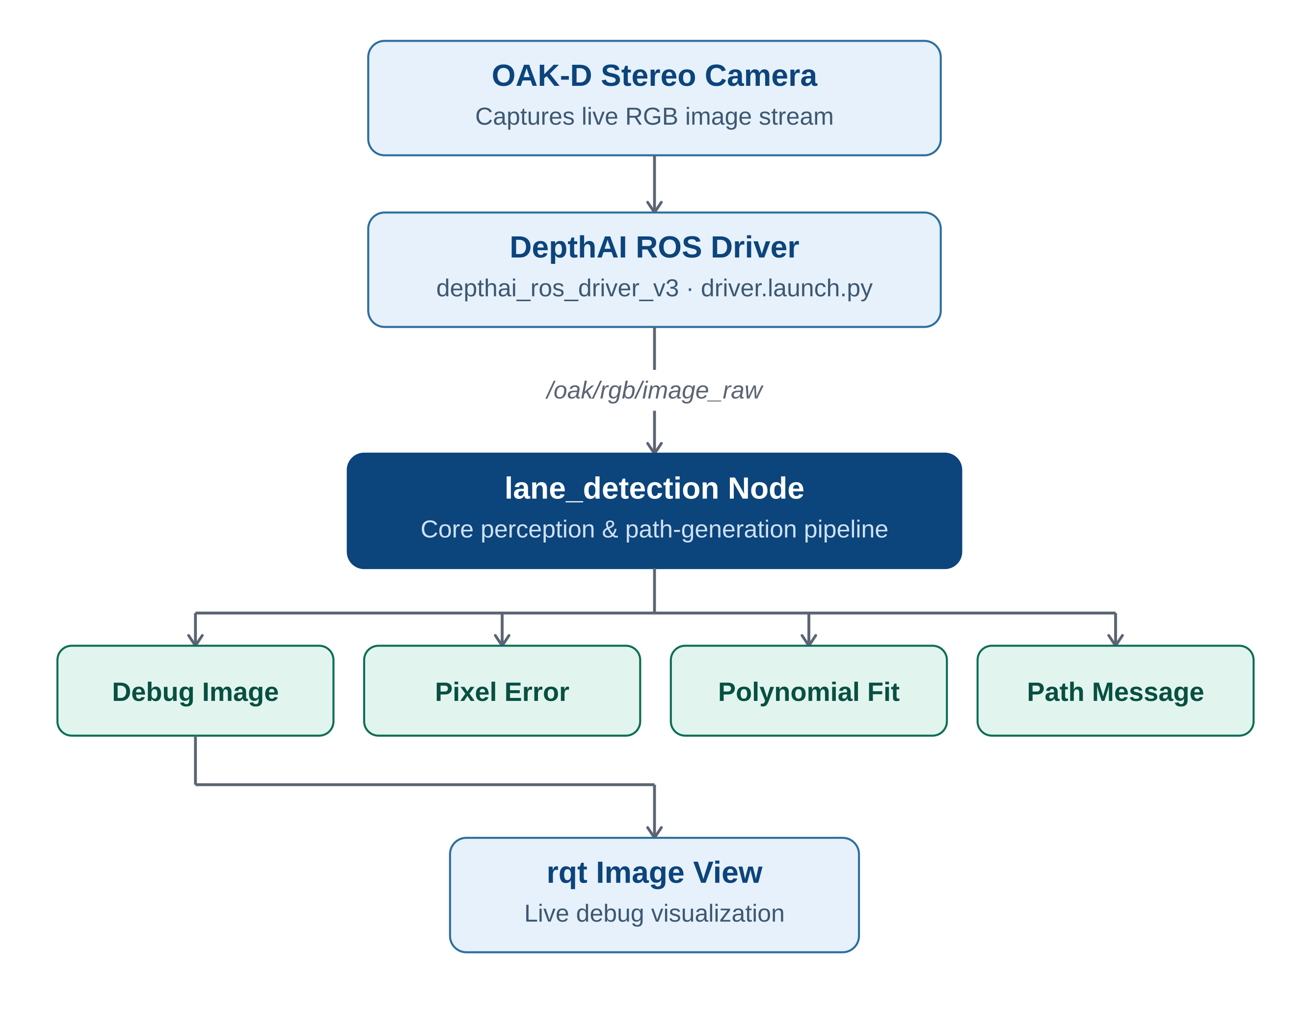
Figure 1 — End-to-end software architecture

System Components
Component | Description
OAK-D Camera | Captures live RGB images
DepthAI ROS Driver | Publishes camera topics
lane_detection | Detects lane markings and generates the driving path
rqt Image View | Displays the processed debug output

3. Prerequisites
Ensure the following software is installed before building the workspace.
Software | Version
Ubuntu | 22.04
ROS | Humble
OpenCV | 4.x
Python | 3.10
Colcon | Latest
DepthAI ROS Driver | Installed
OAK-D Camera | Connected

4. Building the DepthAI ROS Driver
Clone the repository.
cd ~/ros2_ws/src
git clone https://github.com/luxonis/depthai-ros.git

Return to the workspace and build.
cd ~/ros2_ws
colcon build --symlink-install

Source the workspace.
source install/setup.bash

5. Building the Lane Detection Package
Copy the package into ros2_ws/src.
Build only the lane_detection package:
cd ~/ros2_ws
colcon build --packages-select lane_detection --symlink-install

...or build the entire workspace:
colcon build --symlink-install

Source the workspace.
source install/setup.bash

6. Running the Lane Detection Pipeline
The implementation requires three terminals running concurrently.

Terminal 1 — Launch the camera
source ~/ros2_ws/install/setup.bash
ros2 launch depthai_ros_driver_v3 driver.launch.py

Terminal 2 — Run the lane detection node
source ~/ros2_ws/install/setup.bash
ros2 run lane_detection lane_detection

Terminal 3 — Launch the visualizer
rqt
Navigate to:
- Plugins → Visualization → Image View
Select /lane/debug_image. The live processed lane visualization will be displayed.

7. Lane Detection Algorithm Implementation
The lane detection algorithm consists of several computer vision stages executed sequentially for every incoming camera frame.

7.1 Image Acquisition
The node subscribes to /oak/rgb/image_raw using sensor_msgs/Image. The image is converted into an OpenCV matrix using CvBridge.

7.2 Camera Undistortion
The OAK-D camera calibration parameters are used to remove radial lens distortion. The OpenCV function cv2.undistort() generates a geometrically corrected image.

7.3 Perspective Transformation
The corrected image is converted into a bird's-eye view. The transformation uses source points and destination points through:
cv2.getPerspectiveTransform()
cv2.warpPerspective()
This simplifies lane estimation by making lane boundaries approximately parallel.

7.4 Yellow Lane Detection
The left lane boundary is extracted using HSV colour segmentation. Processing stages include:
- HSV conversion
- Colour thresholding
- Morphological opening
- Morphological closing
- Contour filtering
Only contours larger than a specified minimum area are retained.

7.5 Dashed Lane Detection
The centre dashed lane is detected independently. The processing stages are:
- CLAHE enhancement
- Adaptive thresholding
- Gaussian blur
- Canny edge detection
- Morphological filtering
- Contour validation
Contour validation considers area, elongation, and solidity.

7.6 Polynomial Curve Fitting
Detected lane pixels are approximated using a second-order polynomial, x = Ay² + By + C, fitted with numpy.polyfit().
Separate polynomials are maintained for the yellow lane, the centre lane, and the left lane centre. Historical coefficients are averaged to smooth the detected lane.

7.7 Lane Tracking
The algorithm maintains historical lane estimates. If a lane cannot be detected:
- Previous polynomial coefficients are reused
- Sudden lane jumps are rejected
- Recovery mode searches the full image until valid lanes reappear
This improves robustness under noisy conditions.

7.8 Lane Centre Estimation
The driving path is computed as the midpoint between the yellow lane and the centre dashed lane. This produces the Left Lane Centre (LLC), which represents the desired driving trajectory.

7.9 Pixel Error Computation
Vehicle lateral deviation is calculated as:
Pixel Error = Camera Centre - Lane Centre
Error | Vehicle Position
Positive | Vehicle is left of lane centre
Negative | Vehicle is right of lane centre
Zero | Vehicle centred

7.10 Path Generation
The lane centre is converted into the ROS base_link coordinate frame. The node publishes nav_msgs/Path, which can be directly consumed by:
- Pure Pursuit
- MPC
- Stanley Controller
- Other path-following algorithms

7.11 ROS Topics Published
Topic | Type | Description
/lane/debug_image | sensor_msgs/Image | Debug visualization
/lane/pixel_error | Float32 | Vehicle lateral error
/lane/polynomial_coeffs | Float64MultiArray | Lane polynomial coefficients
/lane/status | String | Lane detection status
/lane/left_lane_centre_path | nav_msgs/Path | Generated driving path

7.12 Debug Visualization
The node generates a comprehensive six-panel debug visualization showing each stage of the pipeline:
- Undistorted RGB image
- Bird's-eye view
- Yellow lane segmentation
- Dashed lane segmentation
- Polynomial curve fitting
- Final lane overlay
This visualization enables developers to inspect each processing stage independently.

8. Expected Data Flow
The diagram below summarizes the complete per-frame processing pipeline, from raw image acquisition to published navigation data.
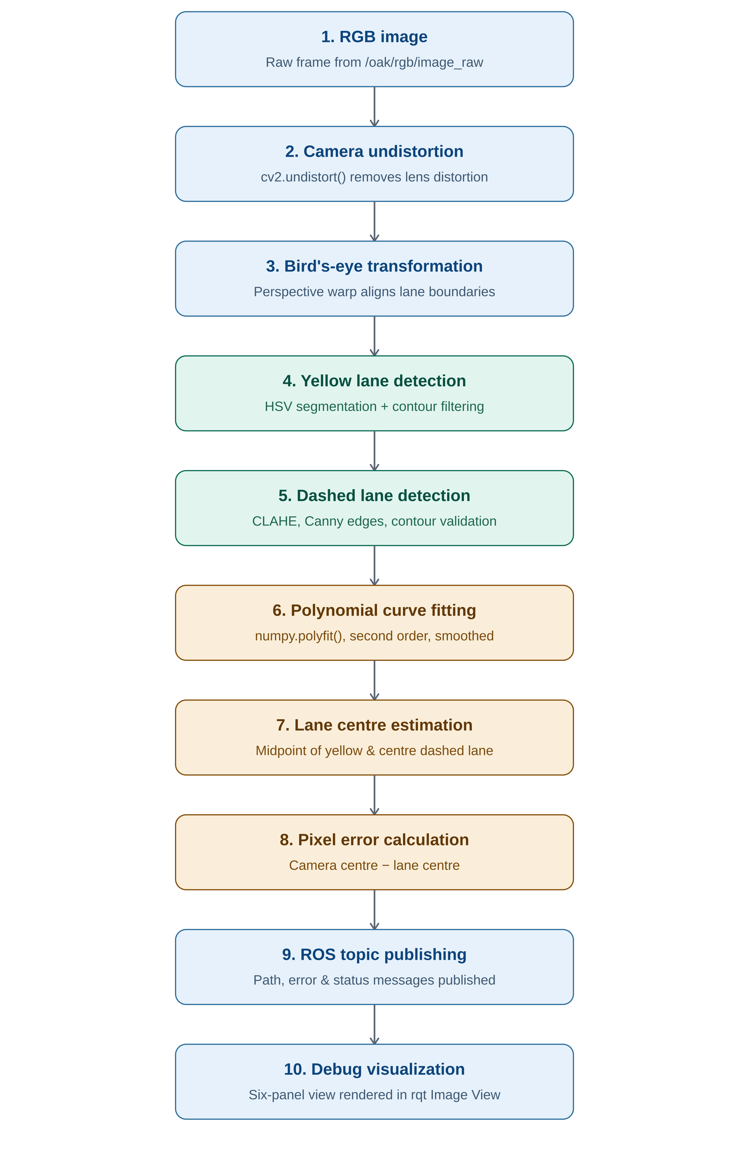
Figure 2 — Per-frame data flow through the perception pipeline

9. Execution Summary
Step | Command
Build workspace | colcon build --symlink-install
Source workspace | source install/setup.bash
Launch camera | ros2 launch depthai_ros_driver_v3 driver.launch.py
Run node | ros2 run lane_detection lane_detection
View output | rqt -> /lane/debug_image

10. Expected Results
After successful execution:
- The OAK-D camera continuously streams RGB images.
- The lane_detection node performs real-time lane detection.
- Yellow lane boundaries and centre lane markings are extracted.
- Second-order polynomial curves are fitted to the detected lanes.
- The lane centre path is estimated.
- Vehicle lateral deviation is calculated and published.
- Debug visualization is available through /lane/debug_image.
- Navigation information is published for downstream autonomous driving modules.

11. Conclusion
The implemented lane detection system provides a complete real-time perception pipeline for autonomous ground vehicles operating under ROS 2 Humble. By integrating camera calibration, perspective transformation, colour-based lane extraction, polynomial curve fitting, temporal filtering, and path generation, the system produces reliable lane geometry suitable for vehicle control and path planning.
The modular ROS 2 architecture and rich debugging outputs make the implementation straightforward to validate, extend, and integrate with higher-level navigation algorithms such as Pure Pursuit, Stanley, or Model Predictive Control (MPC).

